Coach: Date: Training Length:

Topic: Technical/Tactical:

Organization

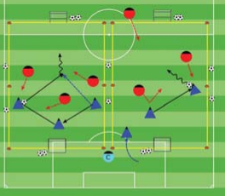

**Activity 1**

**Activity 2**

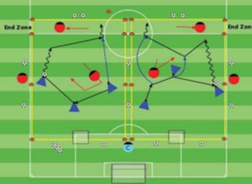

Objective: To score more goals than the opponent. To get players into a game as soon as they arrive.

Organization: Set up two or more 20Wx30L fields with a goal at each end. As the players arrive, play 1v1, 2v1, 2v3, up to 3v3 or 4v4.

Time: 3 games of 2.5 minutes and 30 second

rest for a total of 9 minutes.

Rules: Out of bounds - Pass or dribble the ball i

Key Words: Penetrate, Move the ball to move the opponent, Provide assistance (Behind, Forward and to the Sides of the ball)

Guided Questions: - What are the indicators that the players are being successful? Why should they move the ball backwards and sideways?

Answers: The players are keeping possession for longer periods. Because these passes will move the defenders finding or creating an

opening to pass or dribble forward.

**Key Coaching Points**

**Organization**

**Warm Up**

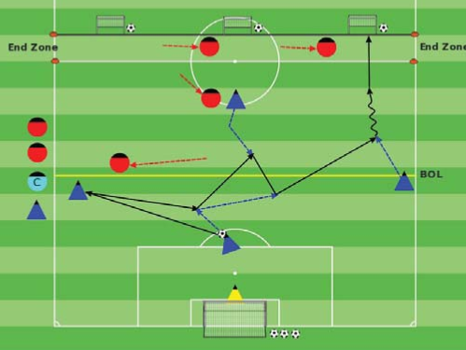

Key Words: Attack the goal, Get on the move

(Behind, sides and in front), Be available to

receive a pass

Guided Questions: - What tells you the players are having fun in the game? - When do you pass backwards instead of forward?

Answer: The players are calling for the ball,

laughing, running,engaged playing the game.

When several defenders are in front of you.

**Key Coaching Points**

**Organization**

Tactical/Technical:

**Key Coaching Points**

**Organization**

**Game**

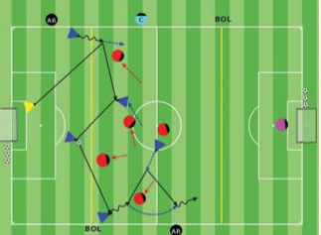

Key Words: Penetrate, Move the ball to move the opponent, Provide assistance (Behind, Forward and to the Sides of the ball)

Guided Questions: - What are the indicators that the players are being successful? Why should they move the ball backwards and sideways?

Answers: The players are keeping possession for longer periods. Because these passes will move the defenders finding or creating an

opening to pass or dribble forward.

Objective: To unbalance and disorganize the opponent to create/find openings

to pass and dribble forward and create scoring chances.

Organization: Play 5v2 + 2 End Zone Guards in a 40Wx35L field with a regular goal and three counter goals. Change the blue and red players every interval.

Scoring: Blue in the counter goals, Red in the regular goal.

Rules: All FIFA Rules Apply. After a goal Blue gets a goal kick, Red passes the ball in from their end line. Build up line is in effect

Organization: Play 3v1 + 1 End Zone Guard in a

20Wx30L field including a 5 yard end

zone and a small goal. Blue dribbles/

passes into the end zone. Red goes to

goal.

Rules: Pass or dribble the ball in.

**Key Coaching Points**

**Organization**

Key Words: Penetrate, Move the ball to move the opponent, Provide assistance (Behind, Forward and to the Sides of the ball), Be available to receive a pass.

Guided Question- What did the players learn from the main activity?

Answer: When to pass forward, backwards or sideways in order to keep possession and create or find an opening to pass or dribble forward

Objective: To unbalance and disorganize the opponent in order to pass and dribble forward.

Organization: With the players at practice, create two equal teams. Play in a 40Wx60L field with regular goals.

Time: 2 halves of 13 minutes, 2 minutes rest for

a total of 30 minutes.

Rules: All FIFA Laws apply